Day 2 Lab Programs

1.Implement a Python program for a Checkers AI agent using the Minimax algorithm with Alpha–Beta pruning. The program should:

a) Represent the Checkers board and its legal moves.
b) Allow two players (Human vs AI) or (AI vs AI) to play.
c) Use Minimax with Alpha–Beta pruning for the AI’s decision-making.
d) Display the board after every move and declare the winner at the end.

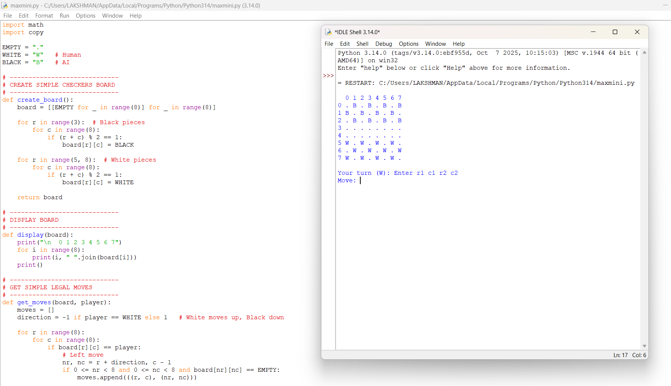

2.Implement a Python program to simulate the Tic Tac Toe game. The program should:

a) Represent the 3×3 game board.
b) Allow a human player to play against an AI player.
c) Print the board after each move.
d) Declare the winner or draw at the end of the game.

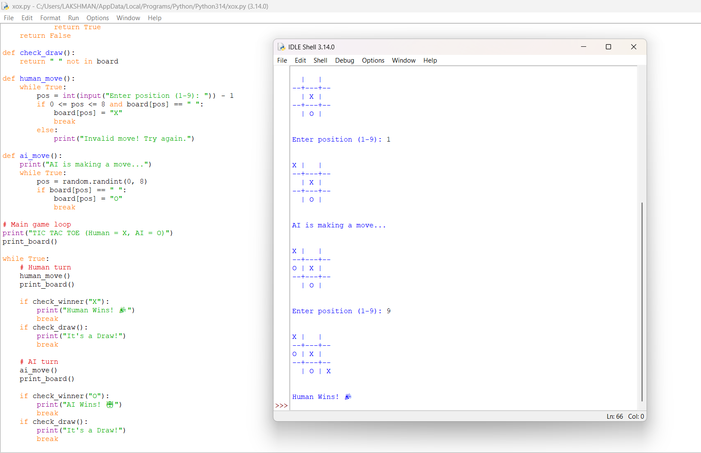

3.Imagine you have a simple autonomous vacuum cleaner, which can move around in a grid-based environment. The grid is divided into cells, some of which are dirty, and some are clean. The vacuum cleaner can move in four directions: up, down, left, and right. Its primary task is to clean all the dirty cells while minimizing its movements. Implement the above AI problem using Python.

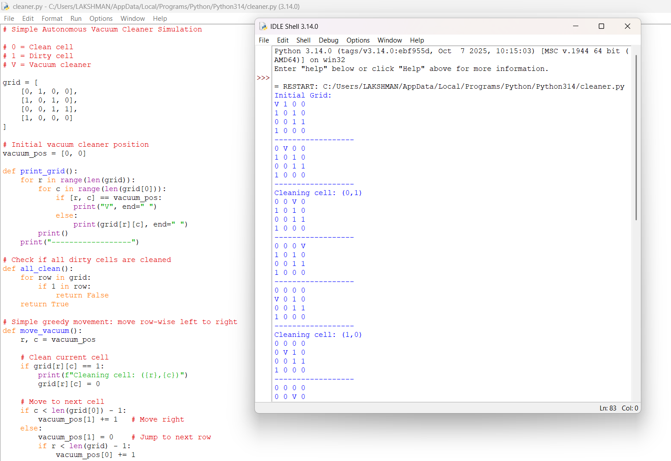

4.Implement a Python program to solve the N-Queens problem using Hill Climbing. The program should:
a) Represent a state as positions of N queens (one per column).
b) Define a cost function = number of attacking pairs of queens.
c) Generate neighbors by moving one queen within its column to a different row.
d) Move to the best neighbor if it strictly improves the cost.
e) Stop when no better neighbor exists (local optimum).
f) (Optional) Use random restarts to increase the chance of finding a global optimum.
g) Print the final board, the final cost, and whether a valid solution (cost = 0) was found.

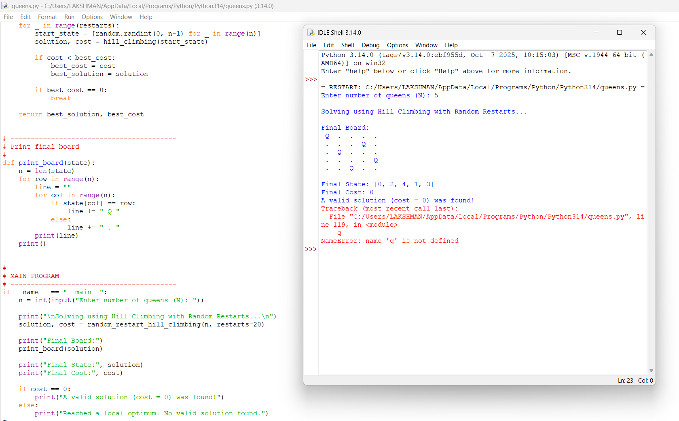

5.Consider a game which has 4 final states and paths to reach final state are from root to 4 leaves of a perfect binary tree as shown below. Assume you are the maximizing player and you get the first chance to move, i.e., you are at the root and your opponent at next level. Using Python create the program, which move you would make as a maximizing player considering that your opponent also plays optimally?

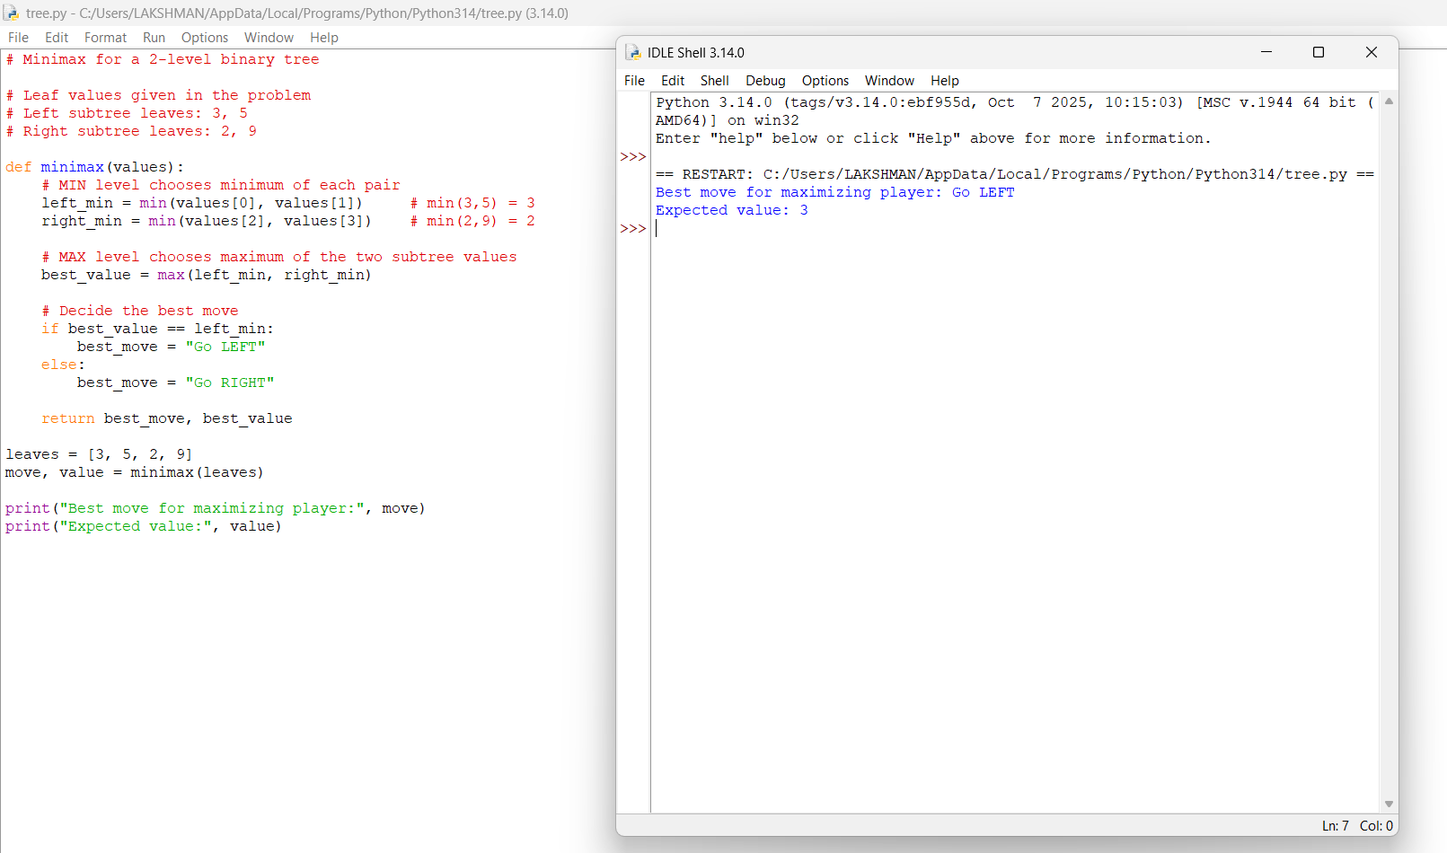

6.Implement a Python program to solve a pathfinding problem using the A* algorithm.
The program should:
a) Represent the environment as a graph or a grid with weighted edges.
b) Take a start node and a goal node as inputs.
c) Use a suitable heuristic function (e.g., Manhattan distance for grids, straight-line distance for graphs).
d) Explore nodes using the A* evaluation function.
e) Print the order of node expansion and the final optimal path with its total cost.
f) Start Node: A
Goal Node: F
Nodes: A, B, C, D, E, F
Edges with weights:
(A, B, 1), (A, C, 4), (B, D, 3), (B, E, 5), (C, F, 2), (D, F, 1), (D, E, 1), (E, F, 2).
(Graph for A* Search: Start = A, Goal = F)

